**Jobsheet-2: CSS**

**Course: Web Design and Programming**

Erwan Majid/08/2i

Link Github: <https://github.com/Majid5654/Semester-3/tree/master/Week2>

* **Practical Section 1. Connecting HTML with CSS**

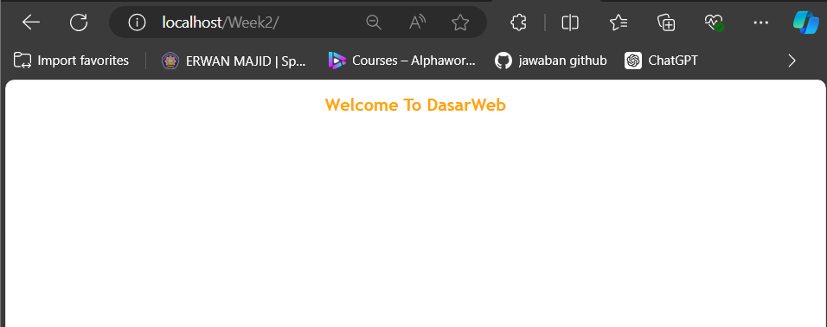

* **Practical Section 2: Use of div**

1. What do you understand from using div on the file? Record below your understanding.

(Question No. 1)

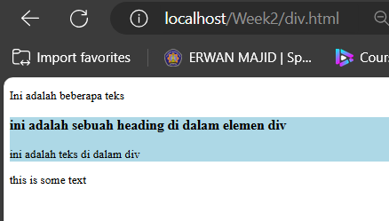

- <div> element is used to group together HTML content, The div element serves as a block-level container for these elements, which allows you to apply styles or manipulate them as a unit.

* **Practical Section 3: Getting to know classes and ids in HTML**

1. What do you understand from the use of class and id in index.html? Record below your

understanding. (Question No. 2)

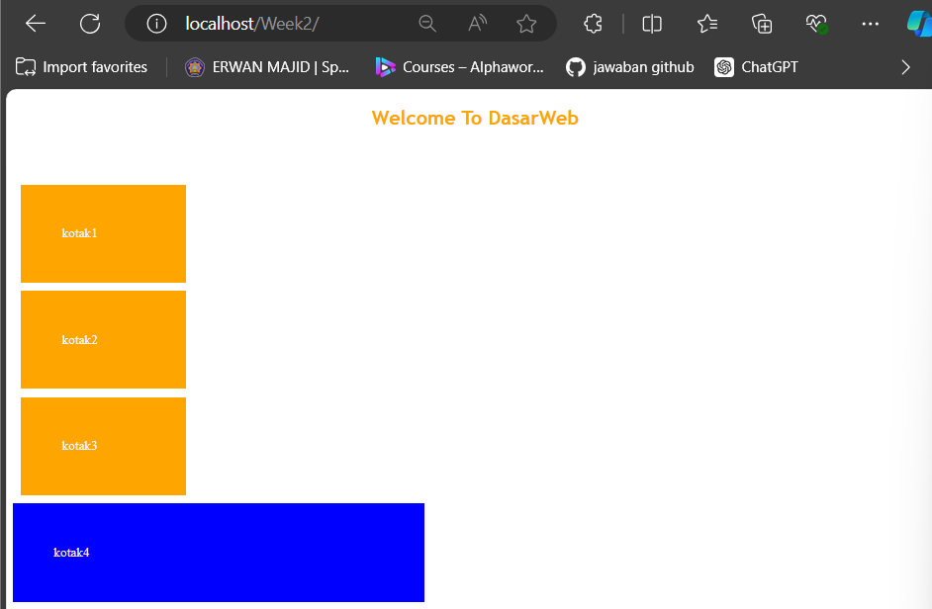

- The class attribute is used to apply the same styling or behavior to multiple elements.

- The id attribute is used to uniquely identify a single element on a page. It must be unique within the HTML document, meaning no two elements can have the same id

-use class when you need to target multiple elements with the same style or behavior, and use id for unique elements that need specific attention

* **Practical Section 4: Changing the Background of a Web Page with CSS**

1. Record your observations and write your answer below. (Question No. 3)

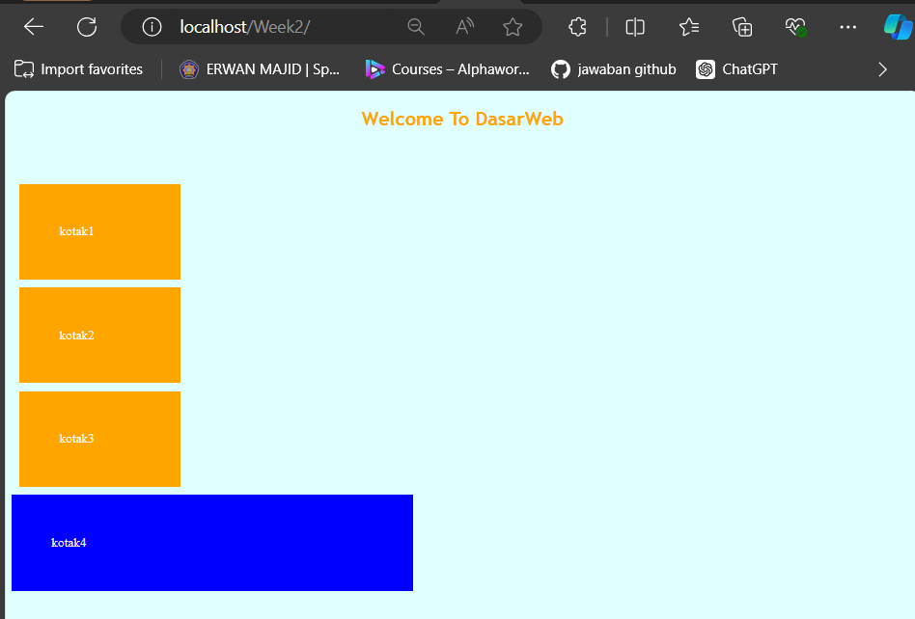

-body: This selector targets the entire HTML document's <body> element, meaning the styling applies to all the content within the body of the page.

background: lightcyan;: This property sets the background color of the body to light cyan (a pale blue-green color).

color: white;: This property changes the text color within the body to white.

* **Practical Section 5: Using images for backgrounds**

1. 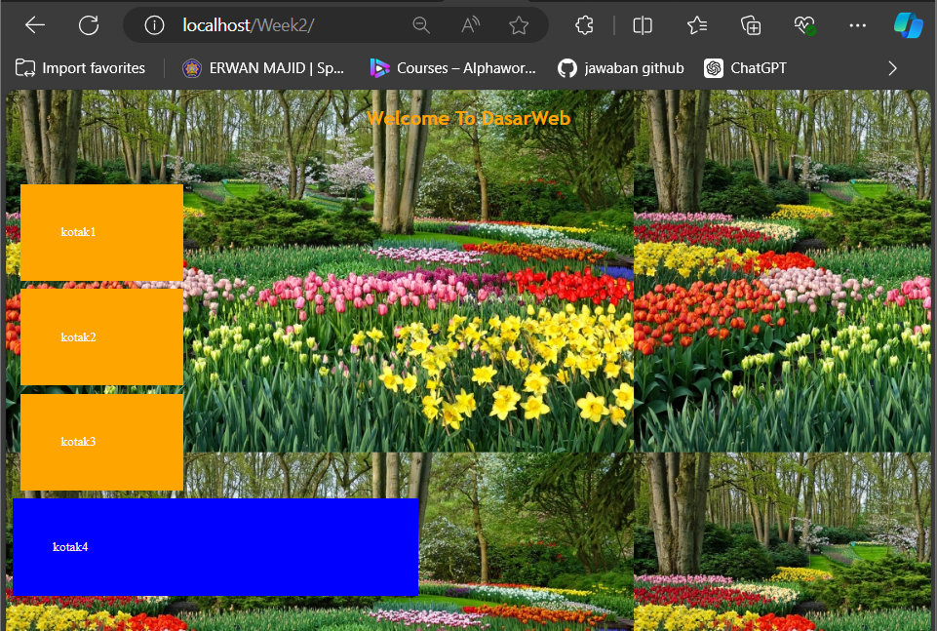Record your observations and write your answer below. (Question No. 4)

-background: url('bunga2.jpg'); This sets the background of the entire webpage (the <body> element) to an image file named bunga2.jpg. The image will be displayed as the background, repeating by default if it is smaller than the viewport

1. Record your observations and write your answer below. (Question No. 5)

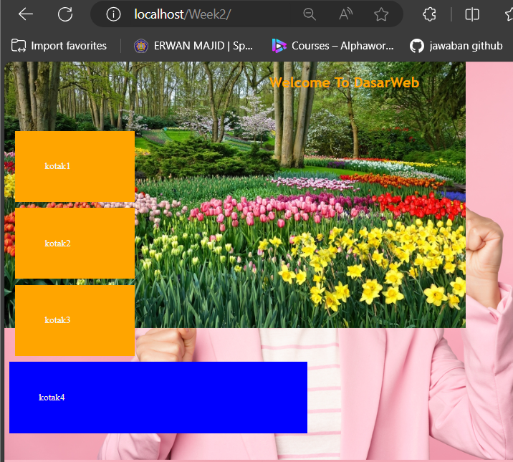

-The first image (bunga2.jpg) will be applied on top.

The second image (orang.jpg) will be layered beneath it.

background-repeat: no-repeat, repeat; this mean no-repeat: The first image (bunga2.jpg) will not repeat.

repeat: The second image (orang.jpg) will repeat both horizontally and vertically.

* **Practical Section 6: Margins and Padding on CSS**

1. 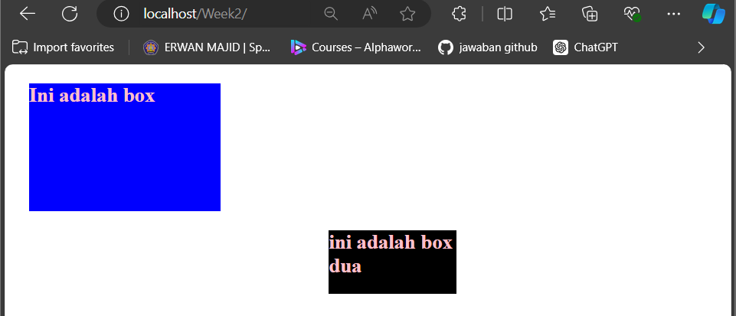Note here what you observe from the code above. (Question No. 6)

-it make two text and with different class,and each class have different style

1. Note here what you observe from the code above. (Question No. 7)

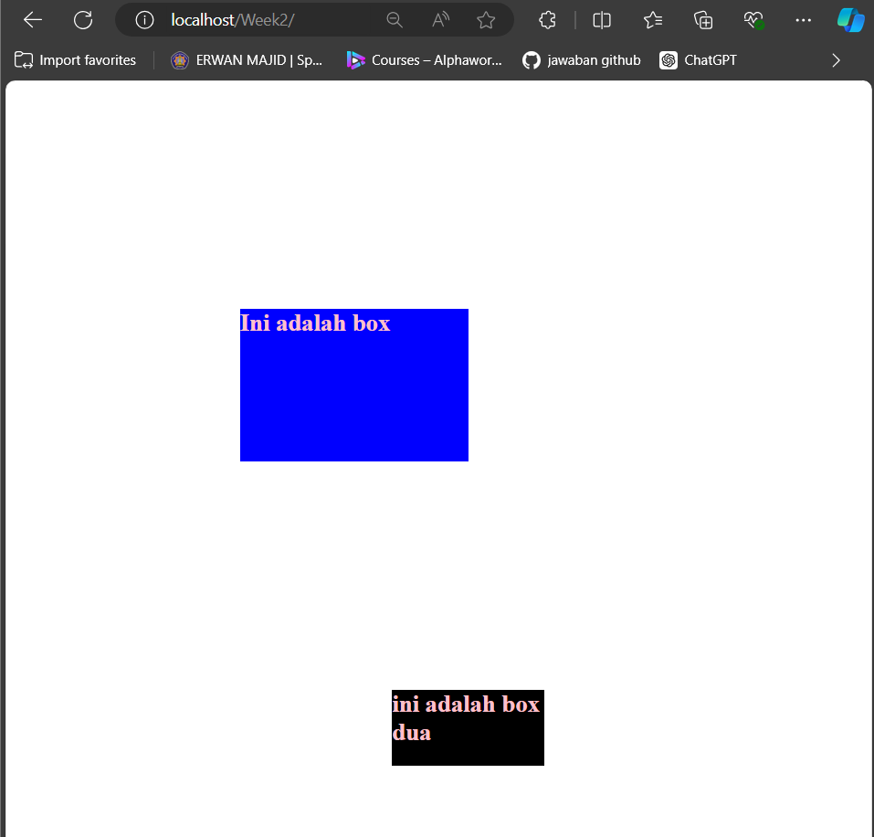

-the element with the class .box will have significantly more space around it.

Now, the .box element will have a much larger 300 pixels of space around it. This pushes the .box much further from any neighboring elements or the page's edges, resulting in much larger gaps on all sides.

* **Getting to Know Padding in CSS**

1. Record your observations and write your answer below. (Question No. 8)

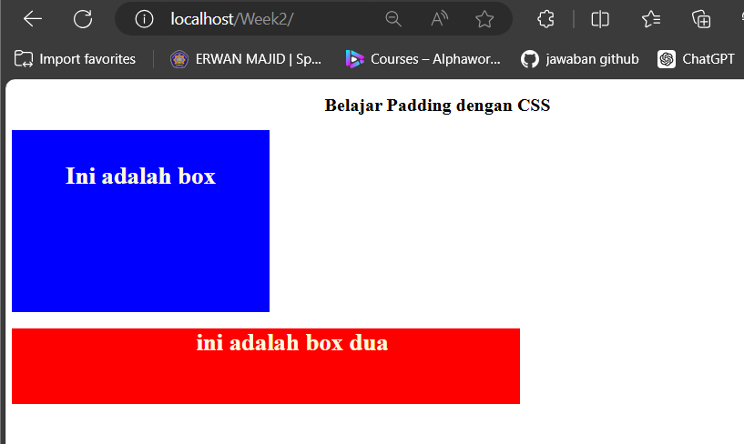

-.box { padding: 20px; }:

This applies 20 pixels of padding on all sides of the .box

Visually, this will create a 20-pixel gap between the blue border and the content within the box.

-box-dua { padding-left: 70px; }:

This applies 70 pixels of padding only to the left side of the .box-dua

1. Record your observations and write your answer below. (Question No. 9)

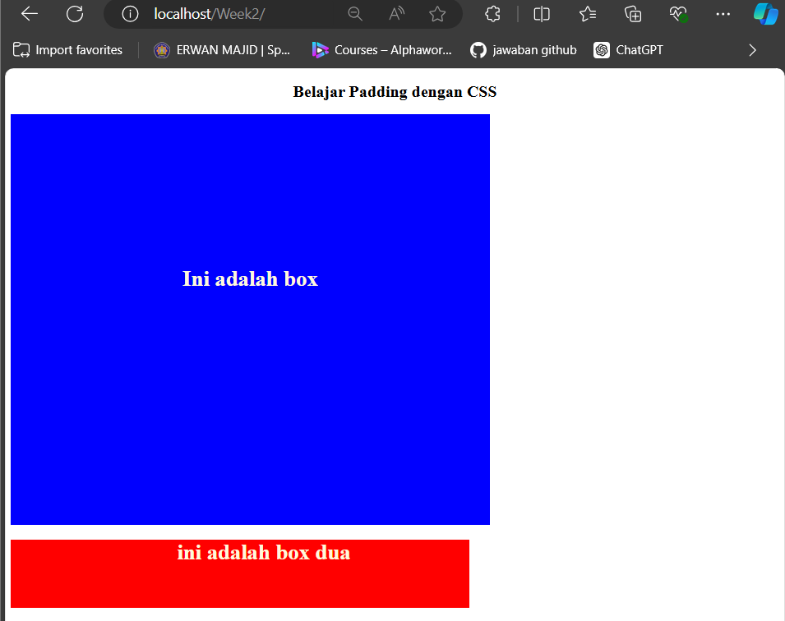

-The padding of 200px applies to all four sides (top, right, bottom, and left) of the .box.

This means that there will be 200 pixels of space between the blue border of the box and the content inside (the <h1>).

* **Practical Section 7: Font Settings in CSS**

1. Record your observations and write your answer below (Question No. 10)

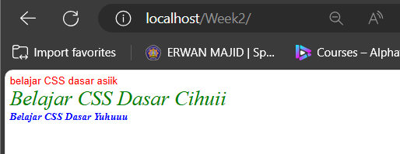

-.tulisan_satu:

color: red;: The text inside the .tulisan_satu class will be red.

font-family: sans-serif;: The font family will be sans-serif, meaning it will use a font like Arial or Helvetica that does not have small decorative lines (serifs) at the ends of letters.

font-style: normal;: The text will have a normal style (not italic or oblique).

-.tulisan_dua:

color: green;: The text inside the .tulisan_dua class will be green.

font-size: 24pt;: The text size will be large, specifically 24 points (a larger font size).

font-style: italic;: The text will appear italicized

-.tulisan_tiga:

color: blue;: The text inside the .tulisan_tiga class will be blue.

font-weight: bold;: The text will be bold, making it appear thicker and more prominent.

* **Practical Section 8: Setting Up Hyperlinks with CSS**

1. Record your observations and write your answer below (Question No. 11)

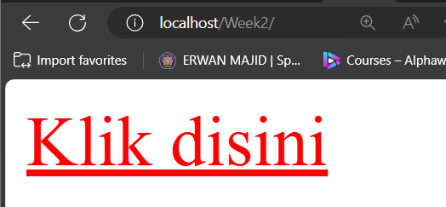

-.Link { font-size: 20pt; }:

This sets the font size of the link to 20pt, making the text of the link larger than the default size.

The link text ("Klik disini") will appear larger.

.Link:hover { color: red; }:

This applies a hover effect. When the user hovers their mouse pointer over the link, its color will change to red.

.Link:link { color: blue; }:

By default, the link will be blue before it has been visited.

1. Write the code you added here (Question No. 12)

.Link{

font-size: 20pt;

}

.Link:hover{

color: greenyellow;

}

.Link:link{

color: blue;

}

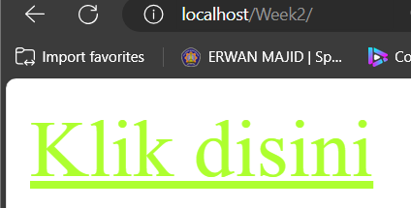

* **Practical Section 9: Formatting Text with CSS**

1. Record your observations and write your answer below (Question No. 13)

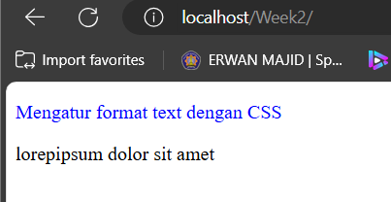

-give a blue color at class ‘tulisan_warna’

1. Write the code you added here (question no 14)

-.tulisan_warna{

color: blue;

text-align: center;

text-decoration: underline;

}

text-align: center; will center the text within its container.

text-decoration: underline; will add an underline to the text.

1. Write the code you added here (question no. 15)

-.par1{

color: navy;

text-decoration: underline;

}

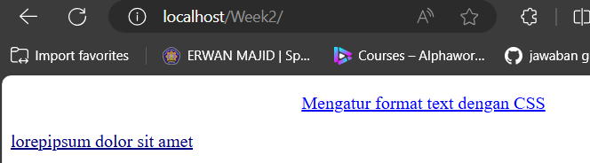

1. Write the code you added here (question no 16)

.tulisan_warna{

color: blue;

text-align: center;

text-decoration: underline;

letter-spacing: 5px;

}

.par1{

color: navy;

text-decoration: underline;

letter-spacing: 5px;

}

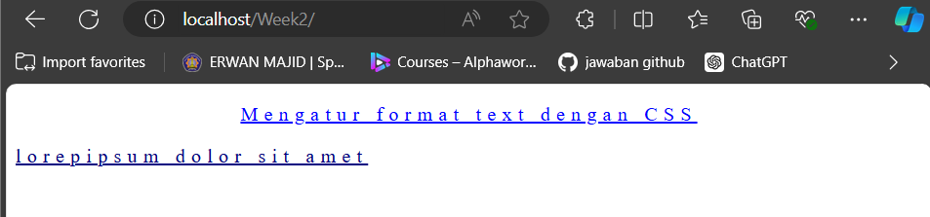

* **Practical Section 10: Getting to Know CSS Positions**

1. 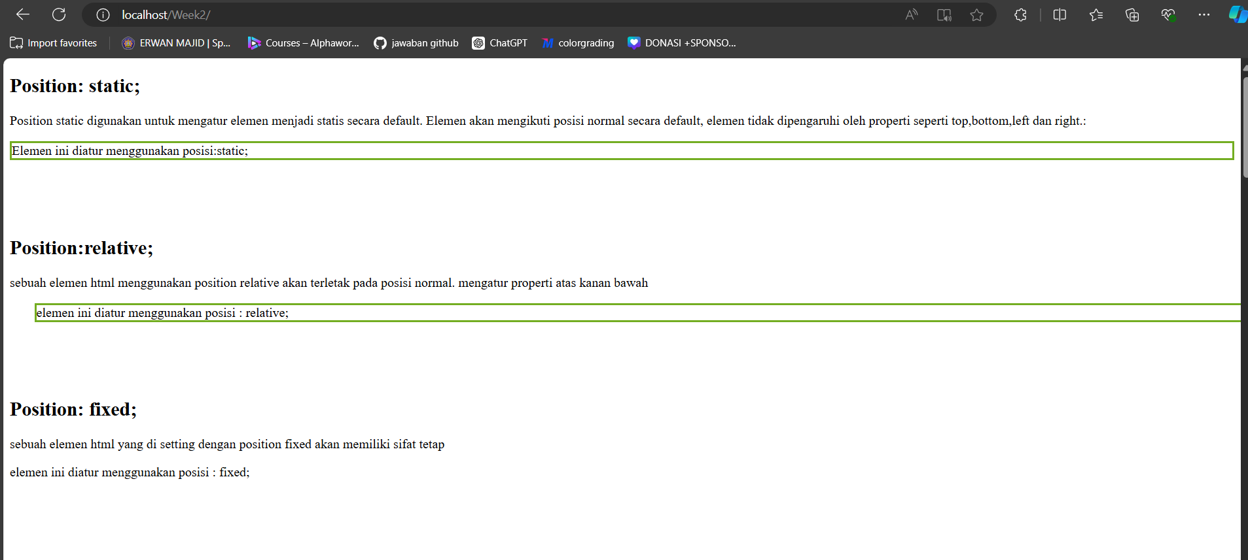Record your observations and write your answer below (Question No. 17)

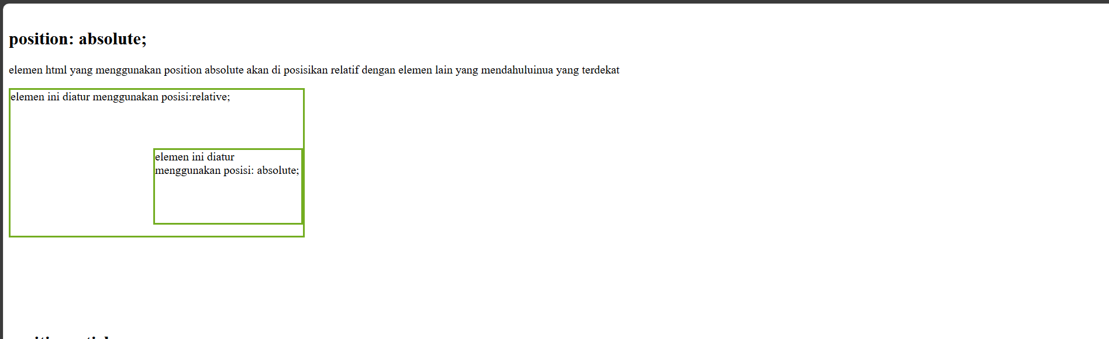



-Static (position: static): This is the default position. The element follows the normal flow of the document.

Relative (position: relative): The element is positioned relative to its normal position

Fixed (position: fixed): The element is fixed relative to the browser window, it stays in the same place even when you scroll.

Absolute (position: absolute): The element is removed from the normal document flow and is positioned relative to the nearest positioned ancestor (like relative).

Sticky (position: sticky): The element behaves like relative until a certain scroll point, where it becomes fixed. It "sticks" when you scroll past it.

* **Practical Section 11: Using Floats**

1. 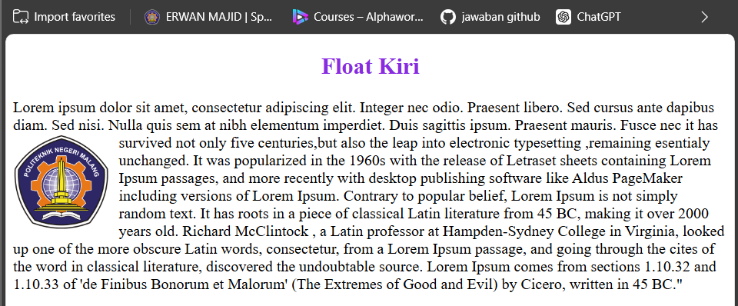Record your observations and write your answer below. (Question No. 18)

-The text and image are wrapped in a div with the class float1.

An image (img) is inserted within the paragraph, alongside a large block of text.

-.gambar: The image is floated to the left (float: left) and resized to 100px width. A margin-right: 10px ensures some space between the image and the text.

* **CSS Display**

1. Observe whether the results of the two programs are the same or different, explain the reason

(Question No. 19)

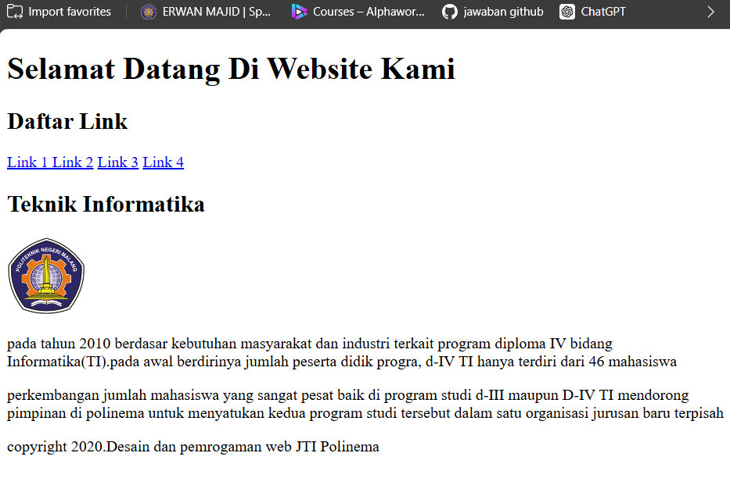

- 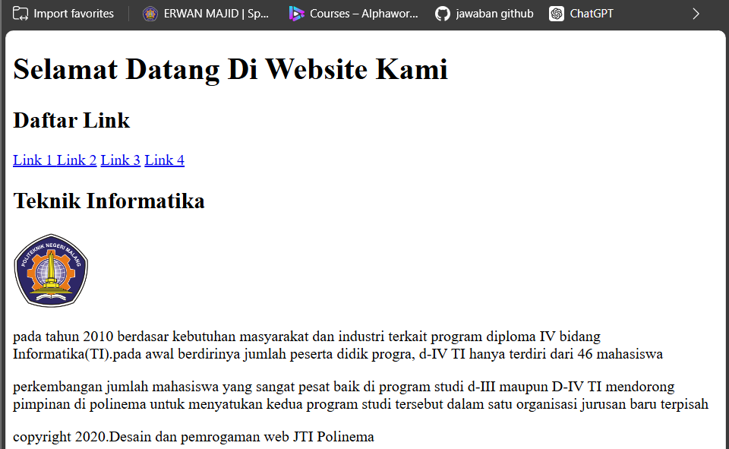

-In last version, the copyright information inside a <div> with the class copyright.

In the previous version, the copyright text was directly inside a <p> element with the class copyright.

No change at all

1. 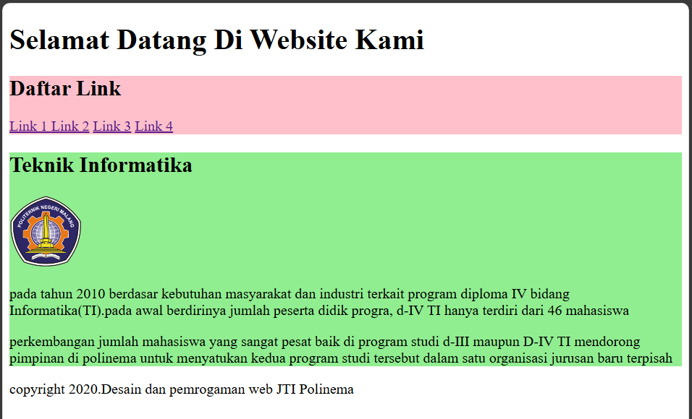Run the code and capture the results. Explain what happened (Question No. 20)

- Elements with the .navigasi class will have a pink background.

The main class will have a light green background

* **Practical Section 13. Inline Display**

1. Run the code and capture the results. Explain what happened (Question No. 21)

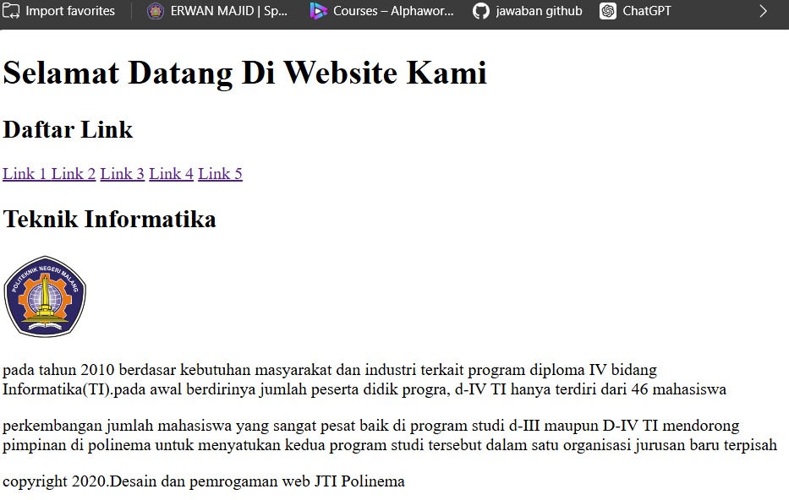

-the text link is add to 5

* **Practicum Section 14. Display inline-block**

1. Run the code and capture the results. Explain what happened. (Question No. 22)

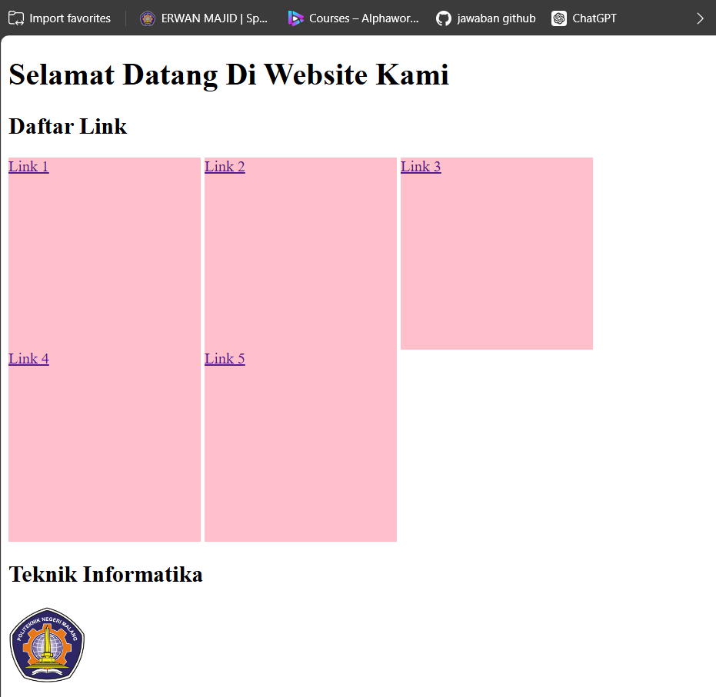

- Each of the links (Link 1, Link 2, etc.) will appear as square blocks (200px x 200px) with a pink background.it because the <a> tags (which represent hyperlinks) are styled to have a pink background and a fixed size of 200px x 200px

* **Practicum Section 15. Display block**

1. Run the program and try to resize the web page. Capture the results, observe and explain

what happened. (Question No. 23)

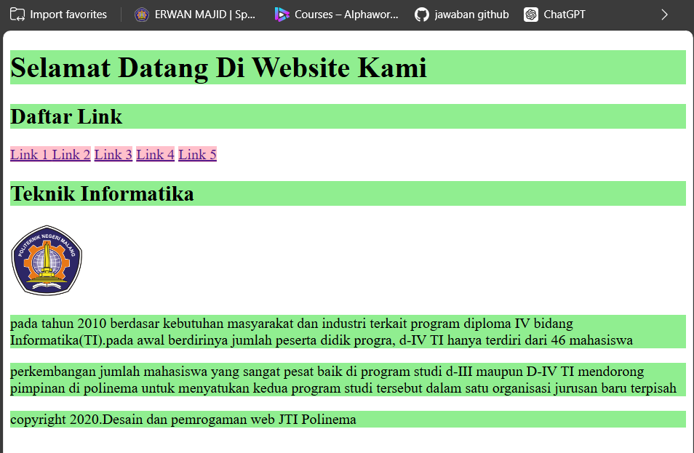

- This sets the background color of all (<h1>), (<h2>), and (<p>) elements to light green.

1. Run the program. Capture the results, observe and explain what happened. (Question No. 24)

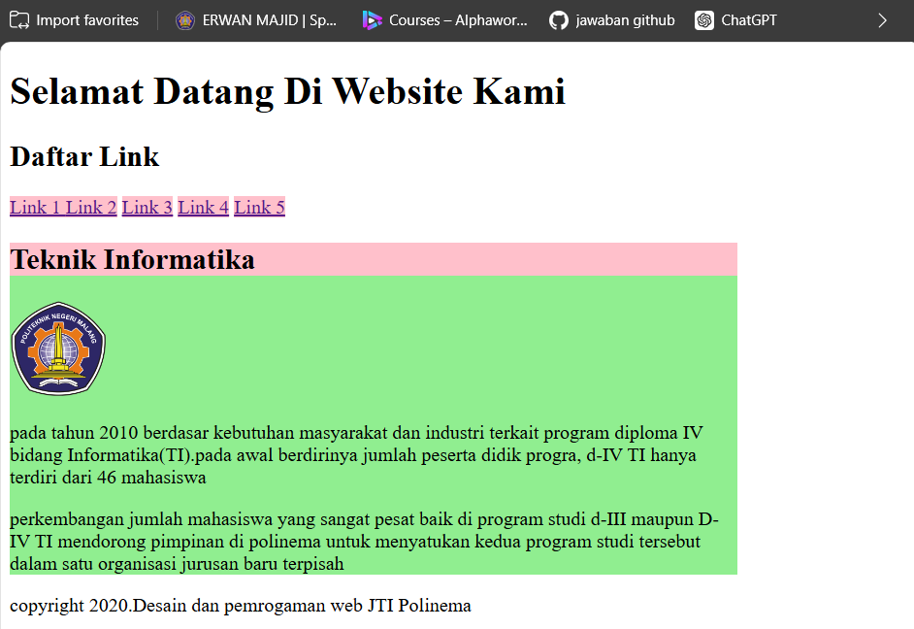

- Elements with the class .main will be 600px wide and have a light green background.

And <h2> with class .main will have a pink background, overriding the light green for that specific heading.

Practicum Section 16. Box Model: Margin

1. Run the program, observe the results and explain it (Question No. 25)

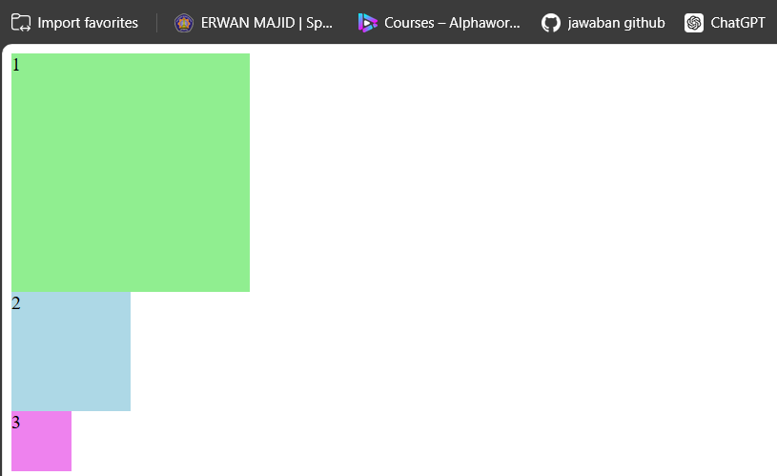

- .satu div has a width and height of 200px with a light green background, the .dua div is 100px by 100px with a light blue background, and the .tiga div is 50px by 50px with a violet background.

1. 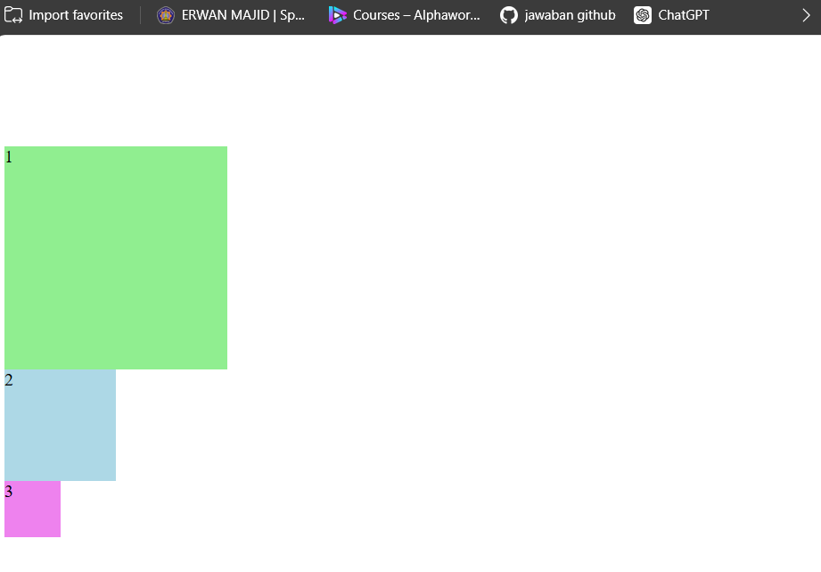Next is to give a margin, where the margin is the transparent area around the box. Add a style to the margin-top marginstyle.css of 100px on class .satu, save it and then run it in a web browser. Capture and observe the results (Question No. 26)

- margin-top: 100px;: This adds 100 pixels of space above the .satu element, creating a transparent area between the top of the .satu div and the content above it.

1. Run the program. Capture the results, observe and explain what happened. (Question No. 27)

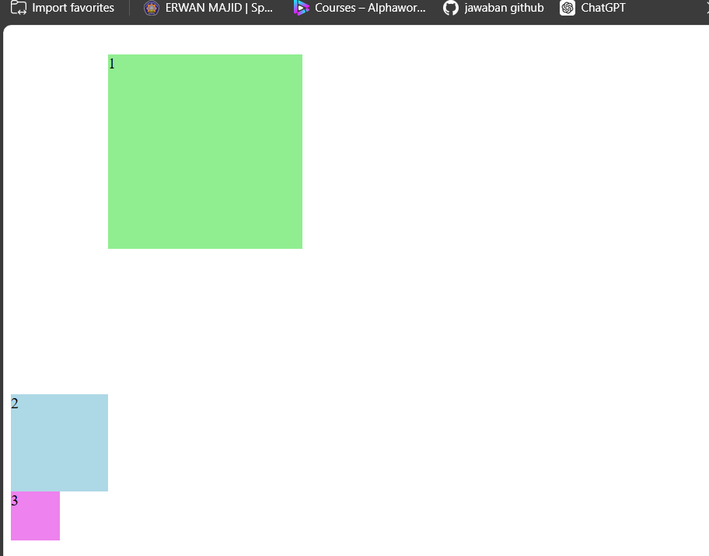

- margin-left: 100px;: Adds a 100px space on the left side of the .satu div.

margin-top: 30px;: Adds a 30px space above the .satu div.

margin-bottom: 150px;: Adds a large 150px space below the .satu div.

margin-right: 50px;: Adds a 50px space on the right side of the .satu div.

* **Practicum Section 17. Flex Box**

1. Run the program, observe the results and explain it (Question No. 28)

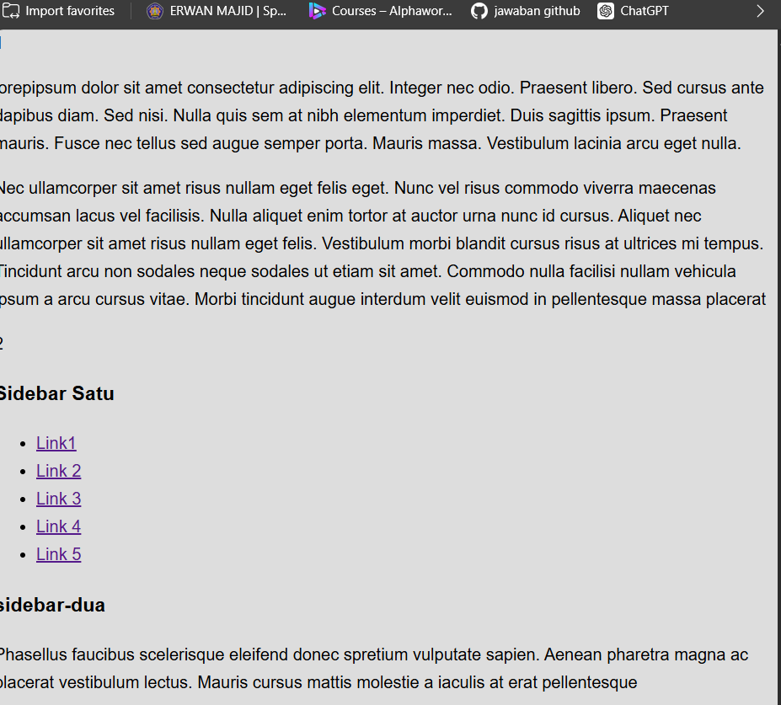

- html, body { margin: 0; padding: 0; }

This resets the default margin and padding of both the <html> and <body> elements to zero.

-font-family: This sets the default font for the entire page to Arial, with Helvetica and sans-serif as fallbacks if Arial is unavailable.

-background-color: #ddd: This gives the body a light gray background (#ddd corresponds to a hex color).

-line-height: 1.65: This increases the space between lines of text

padding-bottom: 1000px: This adds an extra 1000 pixels of space at the bottom of the page.

1. 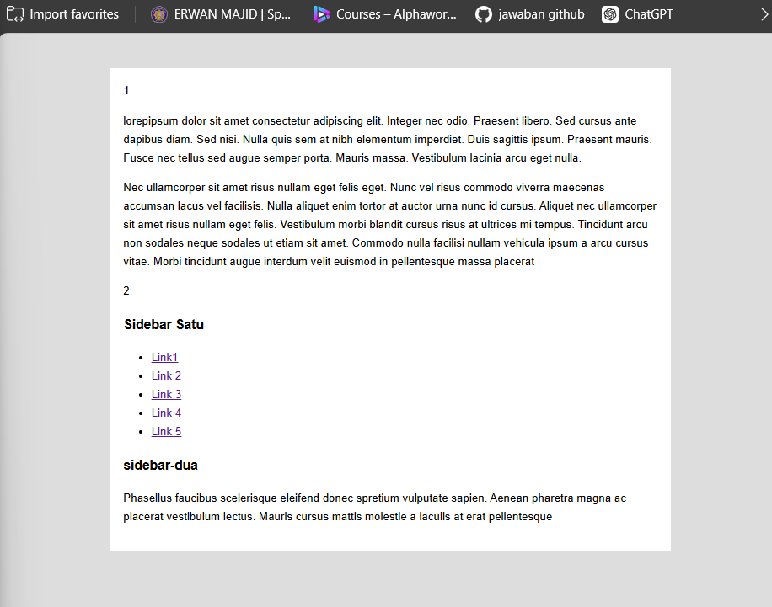Run the program. Capture the results, observe and explain what happened.(Question No. 29)

- .container-satu { width: 800px; margin: 50px auto; background-color: #fff; padding: 20px; box-sizing: border-box; }

-width: 800px: The main container will be 800 pixels wide.

-margin: 50px auto: This centers the container horizontally on the page and adds a 50px margin at the top and bottom. The auto value for the left and right margins ensures it is centered.

-background-color: #fff: The background of the container will be white

-padding: 20px: This adds 20 pixels of space inside the container

box-sizing: border-box: This makes sure that the padding is included in the element’s total width and height, preventing the width of the element from being larger than specified due to padding.

1. Add a display property on a container-satu selector with a flex value. Capture and

explain the result (Question No. 30)

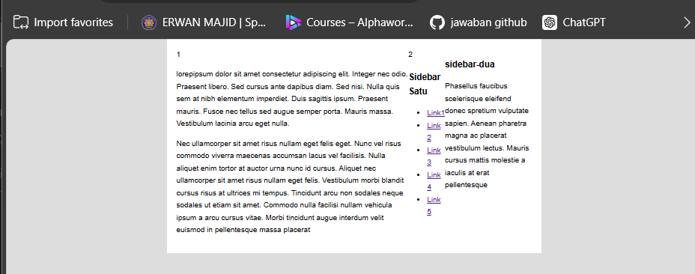

- By default, display: flex; sets the flex direction to row. This means will be placed in a horizontal row, from left to right, and will be aligned according to default flex alignment rules.

* **Practicum Section 18. CSS Grid**

1. Run the program, observe the results and explain it. (Question No. 31)

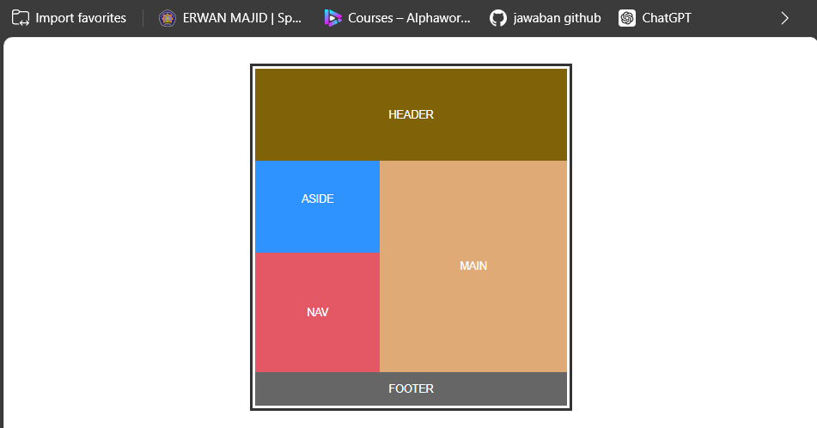

-Container: define the layout with four main sections: header, aside, nav, main, and footer. It splits the content into two columns (1 fraction for the first, 1.5 fractions for the second) and three rows.

Grid Layout:

header spans both columns at the top.

aside is placed in the first column and main in the second column.

nav is below aside, in the first column, while main continues in the second column.

footer spans both columns at the bottom.

1. 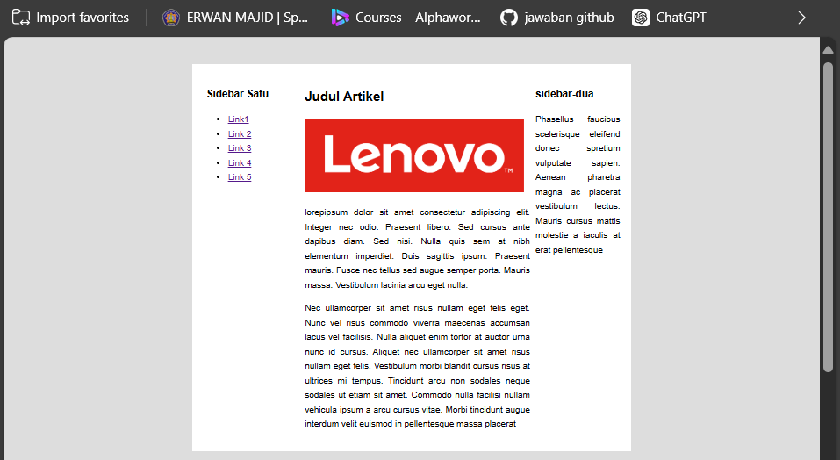JOBSHEET 2 TASKS (Question No. 32)